Errata for
Introduction to the Design and Analysis of Algorithms (-- a Strategic Approach)
by R. C. T. Lee, , S. S. Tseng, R. C. Chang, Y. T. Tsai
McGraw Hill 2005

- Page 18, line 13:
Change “8-2” to “9-2”.
- Page 29, line 9:
Change “if k > 0” to “if k < 0”.
- Page 30, line –6:
Change “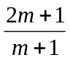” to “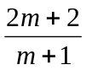”.
- Page 31, line 6:
Change “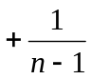” to “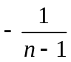”.
- Page 33:
Replace Algorithm 2-4 Quick sort (f,l) by the following:
Input: a_{f} , a_{f+1} , ... , a_{l} .
Output: The sorted sequence of a_{f} , a_{f+1} , ... , a_{l} .
If f ≥ l then Return
X := a_{f}
i := f+1
j := l
While i < j do
Begin
While a_{j} ≥ X and j ≥ f + 1 do
j := j − 1
While a_{i} ≤ X and i ≤ l do
i := i + 1
if i < j then a_{i}a_{j}
End
a_{f}a_{j}
Quicksort( f , j − 1)
Quicksort( j + 1 , l )
- Page 40, line –2:
Change “constants” to “constants for n large enough”.
- Page 40, line –1:
Change “2p” to “2^{p}”.
- Page 57, line 12:
Change “=4 ⋅ 2d” to “=4 ⋅ 2^{d}”.
- Page 58, line 11:
Change “2^{l}” to “2^{i}”.
- Page 58, line 12:
Change “2^{l-1}” to “2^{i-1}”.
- Page 58, line 17:
Change “2^{l-1}” to “2^{i-1}”.
- Page 61, line -4:
Change “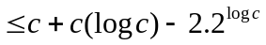” to “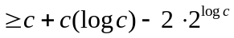”.
- Page 69, line 2:
Change “T(n) = k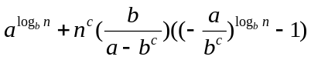” to “T(n) = k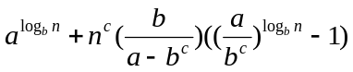”.
- Page 69, Line 3:
Change “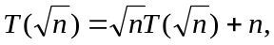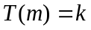and 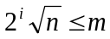” to “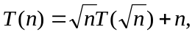and 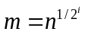”.
- Page 79, line 1:
Change “9“ to “10“.
- Page 79, line 20:
Change “in T “ to “in T’ “.
- Page 137, line 3:
Change “The first step of constructing the HP is to find the two top elements of S_{L} and S_{R}.“ to “Let Hull(S_{L}) and Hull(S_{R}) denote the convex hulls of S_{L} and S_{R} , respectively. There are two line segments between S_{L} and S_{R} to join Hull(S_{L}) and Hull(S_{R}) into a convex hull. Let 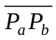 denote the upper segment, where P_{a} and P_{b} belong to S_{L} and S_{R}, respectively. The first step of constructing the HP is to find P_{a} and P_{b}. “.
- Page 137, Figure 4-17
Replace the figure by the following.
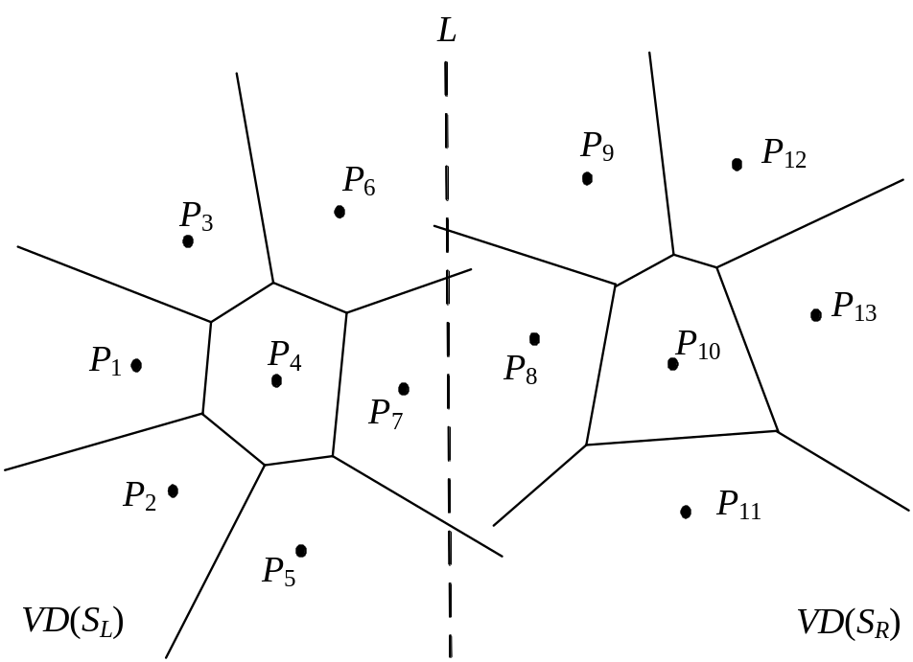
- Page 137, Figure 4-18
Replace the figure by the following.
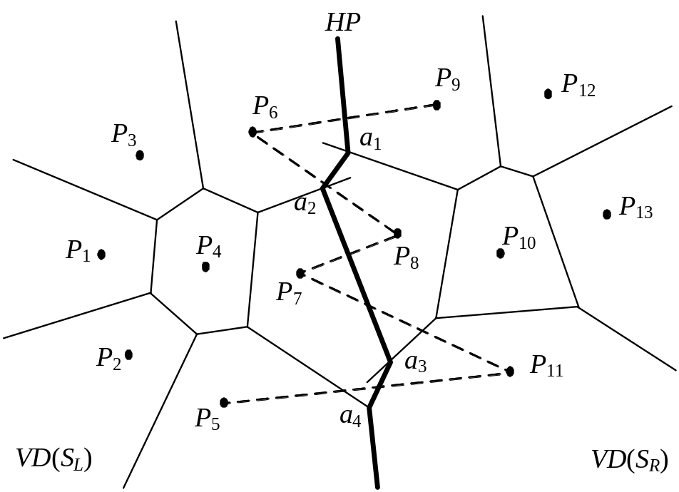
- Page 137, Figure 4-19
Replace the figure by the following.
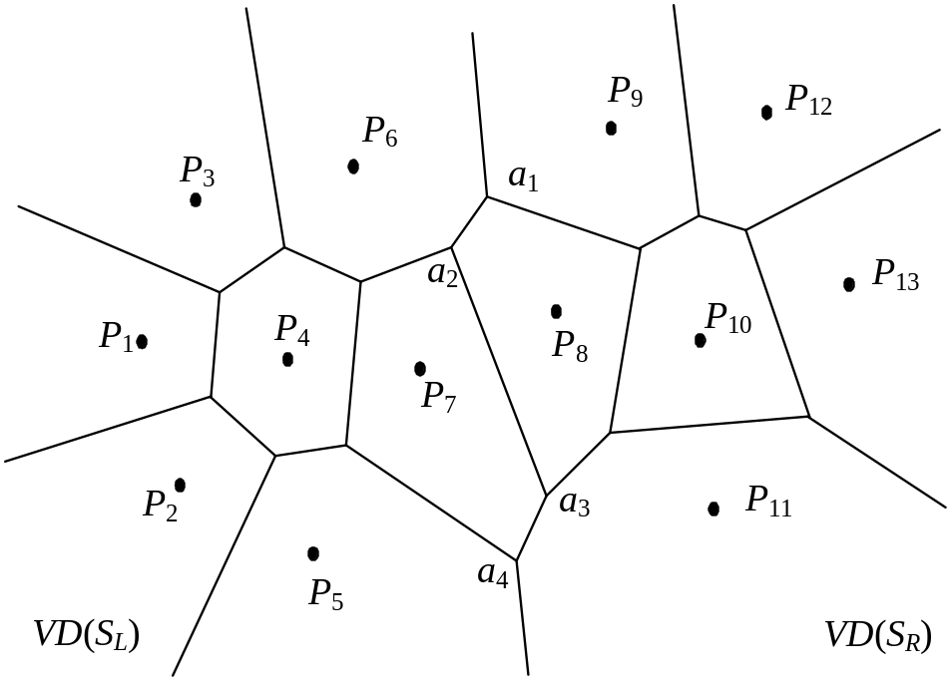
- Page 165, line 6:
Change “and add the first elements” to “and add its”.
- Page 174, line 11:
Change “respectively” to “, respectively”.
- Page 183, line 7:
Change “nX_{i}’s” to “n X_{i}’s”.
- Page 204, Figure 5-40:
Replace the figure by the following:
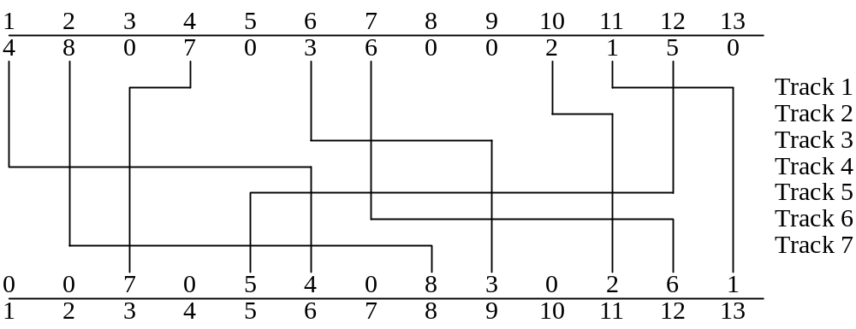
- Page 205, Figure 5-43:
The “2” in the top left circle should be “1”.
- Page 243 line5:
Delete “as n →∞”.
- Page 250, line 3:
Change “x_{m}” and “y_{m}” to “x*” and “y*”, respectively.
- Page 250, Figure 6-26:
Change “x_{m}” and “y_{m}” to “x*” and “y*”, respectively.
- Page 256, line 3:
Change “formula (1)” to “formula (7.1)”.
- Page 268, Table 7-4, redraw the table as follows
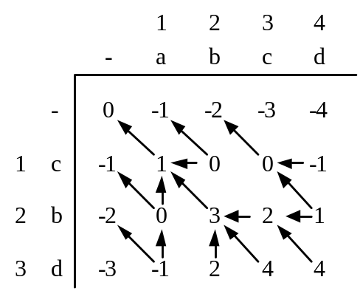
- Page 272, line 10:
Change “pairs in S and i≠k, then either” to “pairs in S, then either”.
- Page 274, line –2:
Change “ (1+M_{i+1,j-1})×ρ(r_{k},r_{j})” to “(1+M_{i+1,j-1})×ρ(r_{i},r_{j})”.
- Page 276, line 15:
Add semicolon “;” to the end of the line.
- Page 277, case (4), line 2:
Change “M_{↓,8}” to “M_{4,8}”.
- Page 277, case (4), line 4:
Change ”max{0,(1+0)×1}” to “max{0,(1+0)×0}”.
- Page 277, case (5), line 4:
Change ”max{0,(1+0)×1}” to “max{0,(1+0)×0}”.
- Page 278, case (8), line 1:
Change ”ρ(r₁,r₆)” to “ρ(r₂,r₇)”.
- Page 278, case (11), line 1:
Change ”ρ(C,C)” to “ρ(C,U)”.
- Page 279, case (13), line 1:
Change ”i=1, j=8” to “i=2, j=8 ”.
- Page 280, case (16), line –2:
Change ”max{2, 0, 1, 1, 0}” to “max{2, 0, 2, 1, 0}”.
- Page 281, case (19), line –2:
Change “max{2, 0, 1, 1, 0, 0}” to “max{2, 0, 2, 1, 0, 0}”.
- Page 281, case (20), line –2:
Change “max{2, 2, 1, 1, 0, 0}” to “max{2, 2, 1, 0, 0, 0}”.
- Page 282, line 3:
Change “O(j．i)” to “O(j − i)”.
- Page 294, line –5:
Change “we shall first consider trees.” we shall focus on trees.”.
- Page 301, Sec. 7-8, line 2:
Change “G(V,E)” to” G=(V,E)”.
- Page 302, line –9:
Change “wt(a)+2wt(b)+wt(a)” to “2wt(a)+wt(b)+wt(b)”.
- Page 305, line 5:
Change “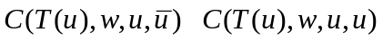” to “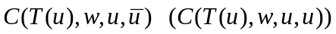”.
- Page 305, line 8:
Change “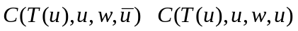” to “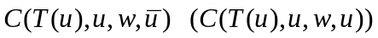”.
- Page 305, line 5:
Change “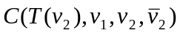” to “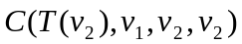”.
- Page 308, Figure 7-42:
Change the figure to the following:
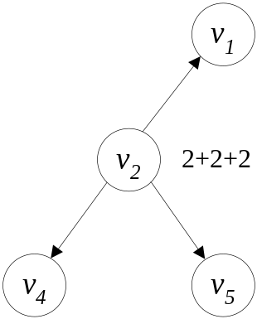

- Page 309, Figure 7-44:
Change the figure to the following:
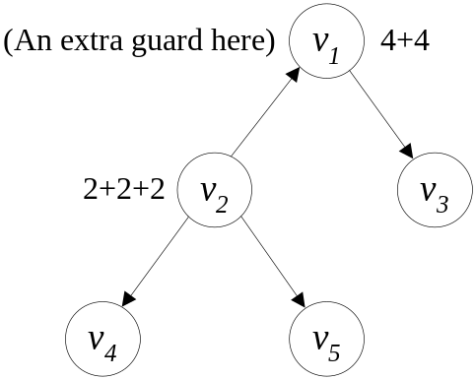
- Page 317, Ex 7.3:
Replace the excise by the following:
For the graph shown as follows, solve the traveling salesperson problem by the branch-and-bound approach. Compare it with the dynamic programming approach.
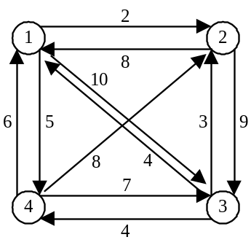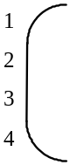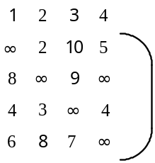
- Page 319, Ex 7.13, line 3:
Change “subsequence S₂ from S₂’ such ” to “subsequence S₂’ from S₂ such”.
- Page 359, line 11:
Change “8-colorable” to “3-colorable”.
- Page 366, line 9:
Change “8-coloring” to “3-coloring”.
- Page 366, line -1:
Change “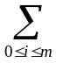” to “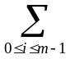”.
- Page 392, Ex 8.12:
Change “8-coloring” to “3-coloring”.
- Page 392, Ex 8.14:
Change “8-dimensional” to “3-dimensional”.
- Page 396, line 2:
Change “S” to “S“.
- Page 426, line 10:
Delete “induced”.
- Page 432, line 14:
Change “π_{i}, π_{i+1}, …, π_{j-1,} and π_{j}, π_{j+1}, …, π_{k-1} in the permutation” to “π_{i}, π_{i+1}, …, π_{j-1} and π_{j}, π_{j+1}, …, π_{k-1} if k > j or π_{k}, π_{k+1}, …, π_{i-1} and π_{i}, π_{i+1}, …, π_{j-1} if k < i in the permutation”.
- Page 436, line -5:
Change “exists” to “exist”.
- Page 437, line 6 of the first paragraph:
Change “see,” to “see in Figure 9-38(b),”.
- Page 438, line 5:
Change “position of π_{r+1} in” to “position of π_{r}+1 in”.
- Page 438, in the caption of Figure 9-39(a):
Change “r = 5” to “r = 2”.
- Page 439, line -1:
Change “transposition ρ(7, 3, 2)” to “transposition ρ(3, 7, 2)”.
- Page 440, the caption of Figure 9-40(c):
Change “and a transposition ρ(7, 3, 2)” to “and a transposition ρ(3, 7, 2)”.
- Page 441, line –1:
Change “S_{OPT} − S_{APX}” to “(S_{OPT} − S_{APX}) ”.
- Page 460, line.-4:
Change “RC(a, b) + RC(a, c) + RC(a, d) + RC(b, c) + RC(b, d) + RC(c, d)” to
” 2(RC(a, b) + RC(a, c) + RC(a, d) + RC(b, c) + RC(b, d) + RC(c, d))”.
- Page 460, line.-3:
Change “1 + 2 + 2 + 1 + 1 + 2” to “2(1 + 2 + 2 + 1 + 1 + 2)”.
- Page 460, line.-2:
Change “9” to “18”.
- Page 461, line.-4:
Change "any node v to m" to "any node u to m".
- Page 461, line.-3:
Change “as the cost” to “as the routing cost”.
- Page 461, line.-1:
Change “≤” to “≥”.
- Page 462, Equation (9-6):
Change “2n-1” to "2n-3".
- Page 465, line.-4:
Change "n/3" to "2n/3".
- Page 467, Equation (9-16):
Change “mrcst(G) ≤ (2n / 3)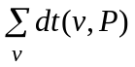” to “mrcst(G) ≥(2n / 3)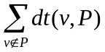”.
- Page 469, line.-5:
Change “i(j+k)+j(i+k)” to "i(j+k)".
- Page 469, line.-4:
Change “j(i+k)+k(i+j)” to "k(i+j)".
- Page 484, line 4 of Ex 9.1:
Change “first-fit (FF)” to “next-fit (NF)”.
- Page 484, line 2 of Ex 9.2:
Change “FF” to “NF”.
- Page 484, line 1 of Ex 9.4:
Change “the” to “an”.
- Page 485, Ex 9.6:
Replace the figure by the following:
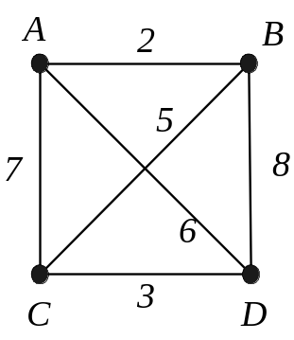
- Page 508, line -9:
Change “decrease key(Δ,x,h)” to”decrease(Δ,x,h)”.
- Page 521, line –5:
Change “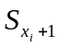”, to “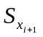”.
- Page 521, line –4:
Change “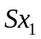”, “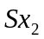” and “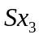” to “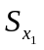”, “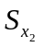” and “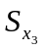”, respectively.
- Page 521, line –2:
Change “” to “”.
- Page 538, line –6:
Change “A(i,j)“ to “A(i,1)”.
- Page 538, line –5:
Delete “=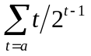”.
- Page 539, lines –2, -3 and –4:
Change “m/n“ to “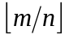”.
- Page 548, line –6:
Delete “”.
- Page 561, lines 3, 4 and 6:
Change “c₀” to “C₀”.
- Page 571, line 2:
Change ”<” to “=”.
- Page 573, line 17:
Change “a number” to “number”.
- Page 573, line –10:
Change “Chapter 4” to “Chapter 3”.
- Page 558, line –12:
Change “in Step 5” to “in Step5 is O(n)”.
- Page 583, line 2:
Change “are” to “is”.
- Page 586, line 2:
Delete “Given a sequence of vertices which will produce T_{onl},”.
- Page 586, line 3:
Change “let” to “A minimum Steiner tree on S is a tree connecting the points in S with minimum length. Let”.
- Page 586, lines 3, 17, 18 and 20:
Change “spanning” to “Steiner”.
- Page 612, line –16:
Change “weighted graph” to “weighted graph G”.
- Page 616, caption of Figure 12-30:
Change “M′_{i} M_{i}'₊₁” to “M′_{i} ⊕ M_{i}'₊₁”.
- Page 646, line 7 of Excise 12.2:
Change “a arriving vertex” to “an arriving vertex”.

